**LISTĂ**

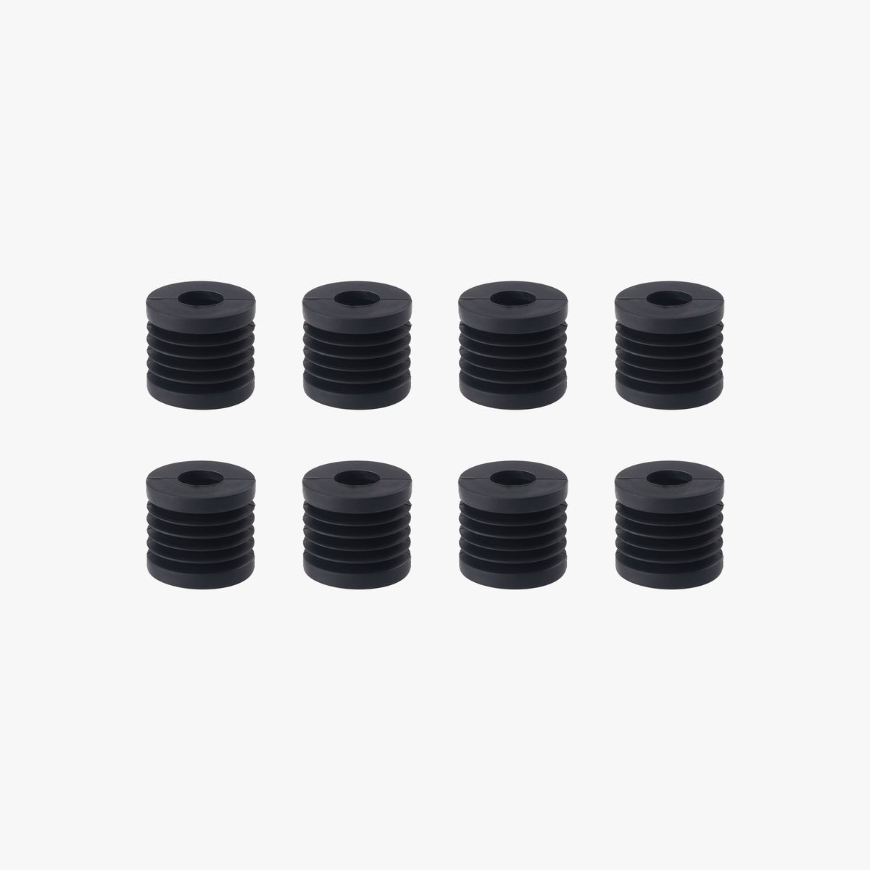

Anti-Vibration Feet

X1 series and P1P

**€10.99**

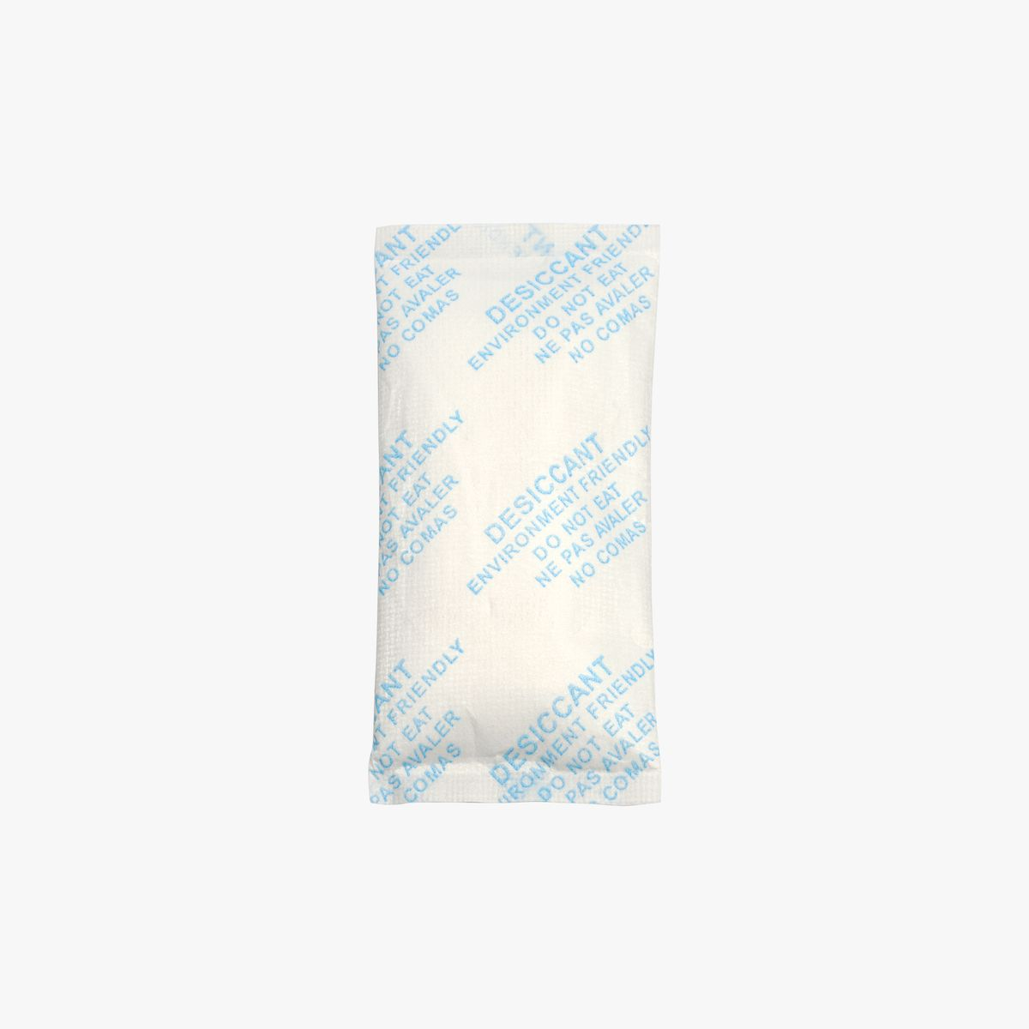

Desiccant for AMS（6 pack） x10

X1 Series and P1P

**€49.90**

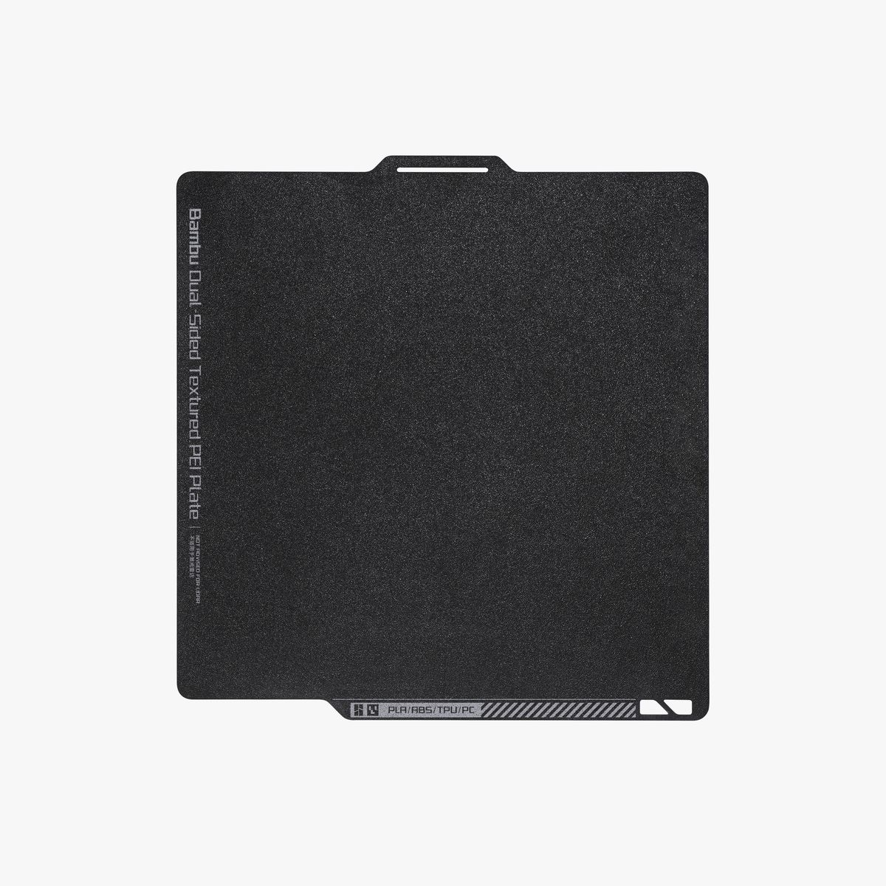

Bambu Dual-Sided Textured PEI Plate

X1 Series and P1P

**€38.99**



Bambu Lab X1 Carbon 3D Printer

**€1.349.00**

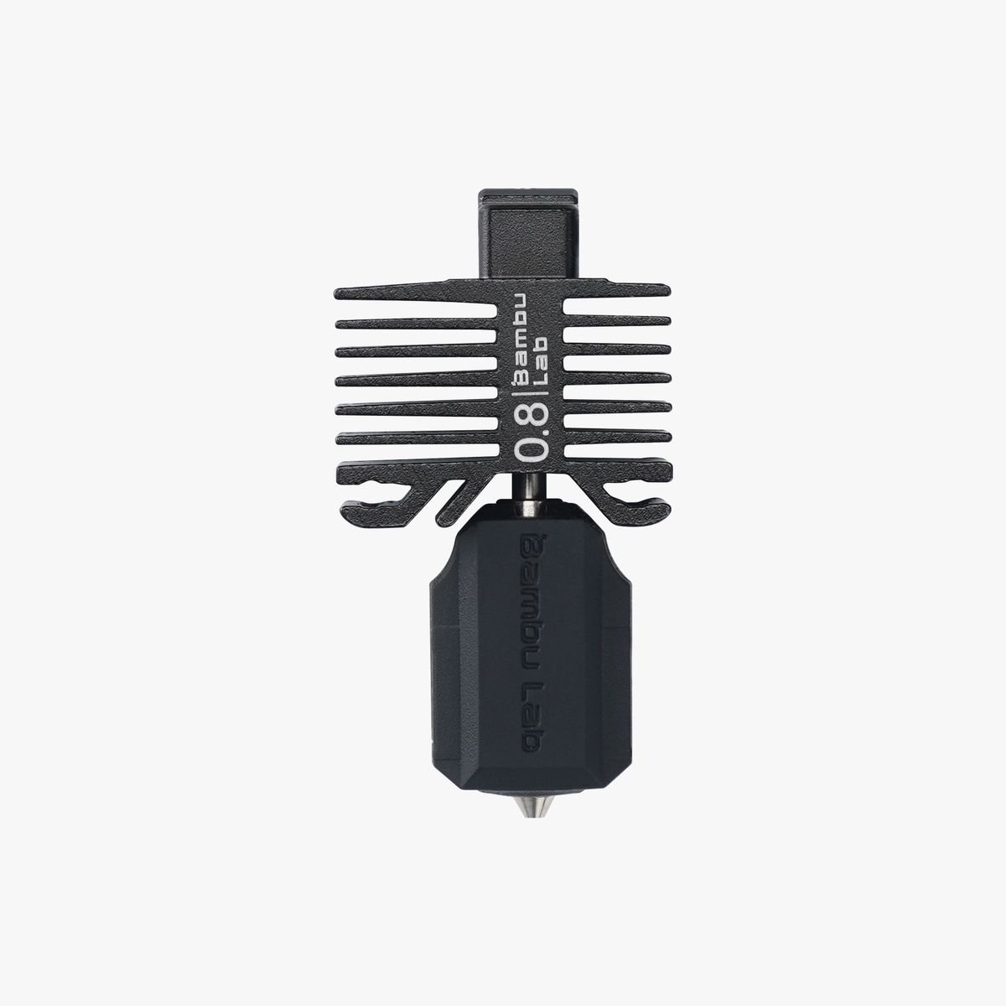

Hotend with Nozzle

0.8mm Hardened Steel / X1 Series and P1P

**€16.99**

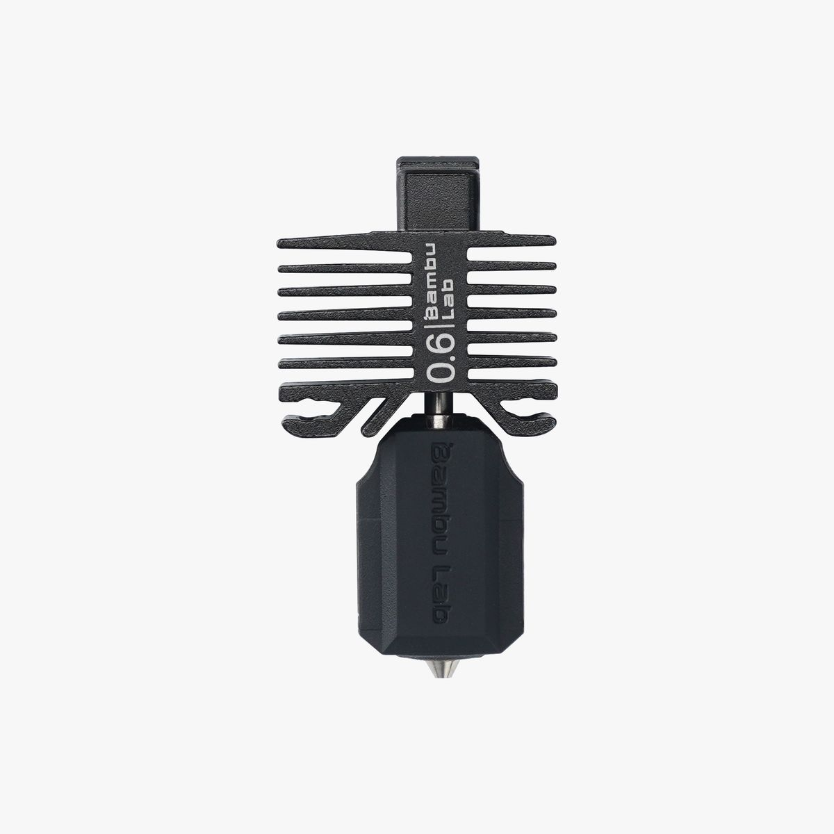

Hotend with Nozzle x2

0.6mm Hardened Steel / X1 Series and P1P

**€33.98**

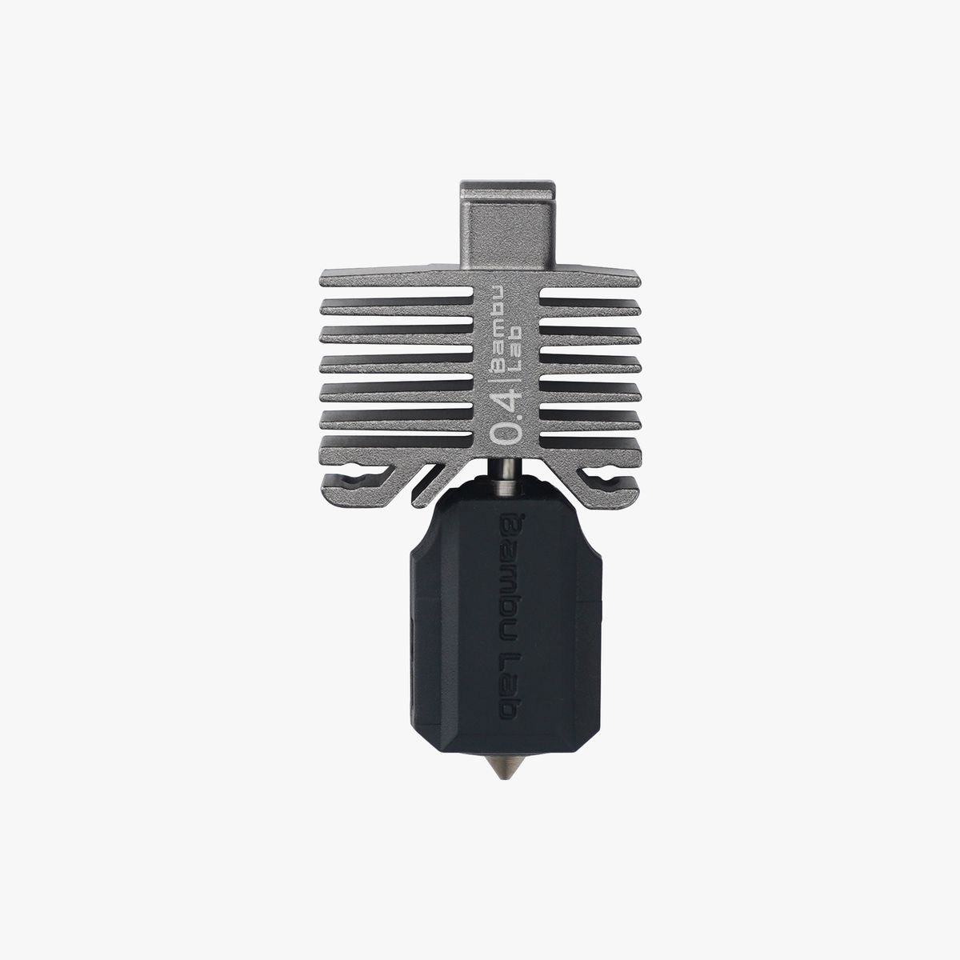

Hotend with Nozzle x3

0.4mm Hardened Steel / X1 Series and P1P

**€50.97**

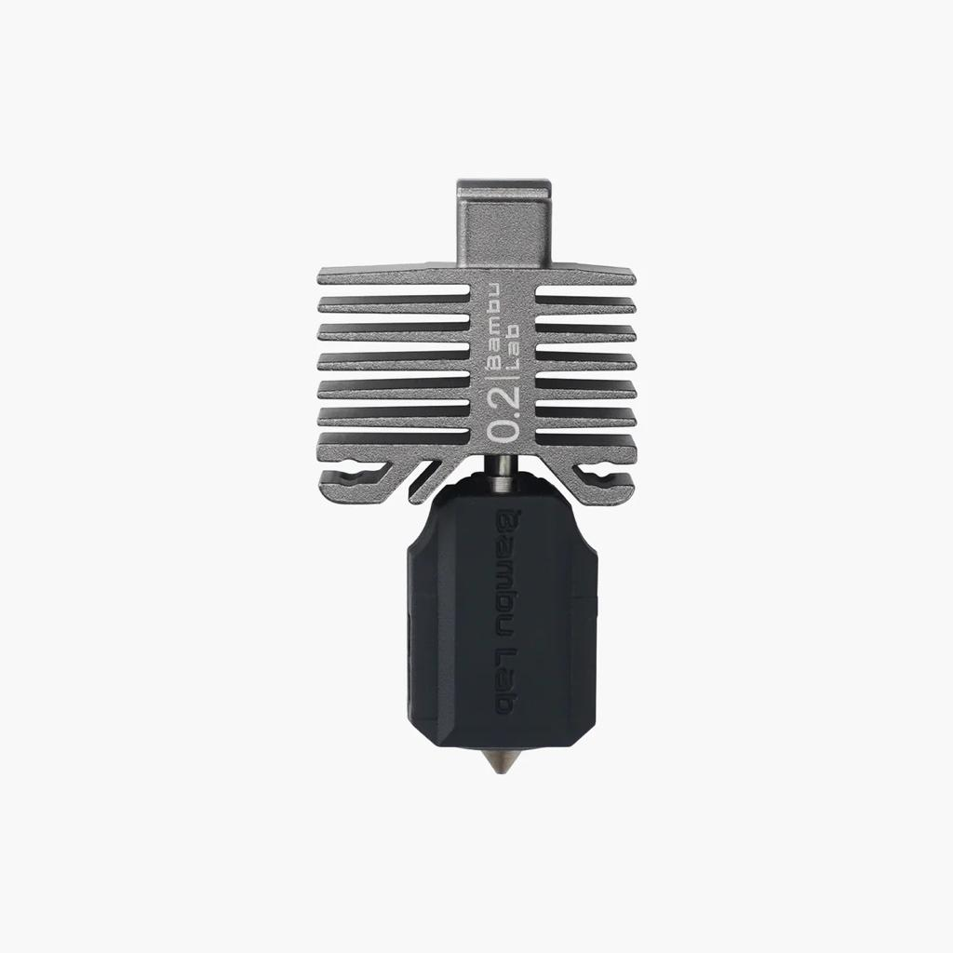

Hotend with Nozzle

0.2mm Stainless Steel / X1 Series and P1P

**€16.99**

**Total componente: €1.567.81**

**+**

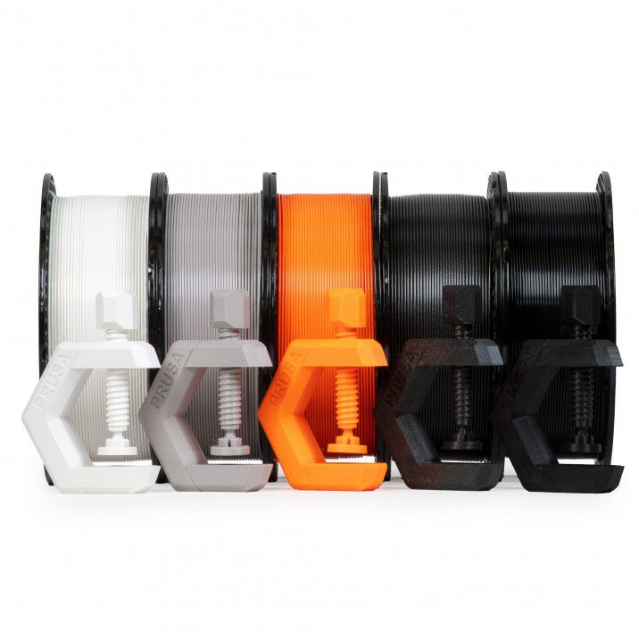

Prusament PETG Best Sellers Pack 4+1 FREE

**€119.99**

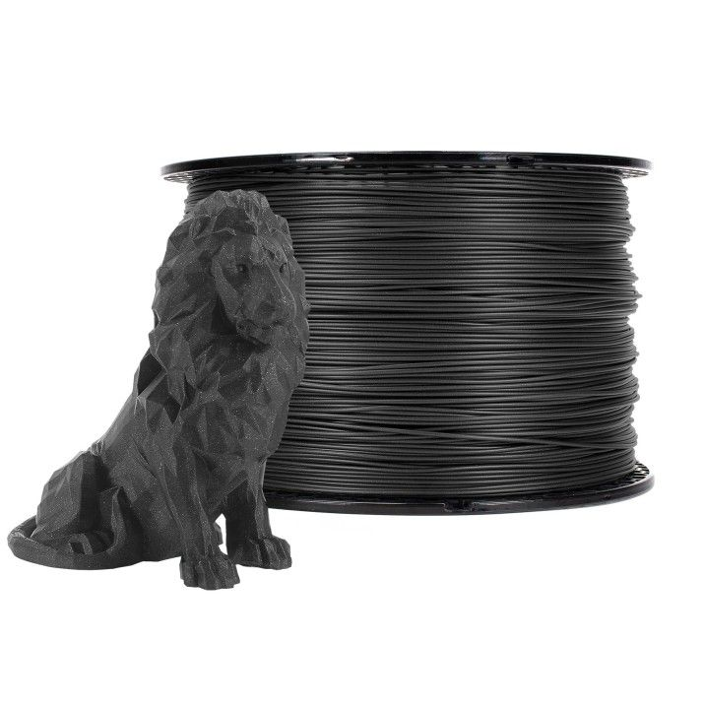

Prusament PLA Prusa Galaxy Black 2kg

**€49.99**

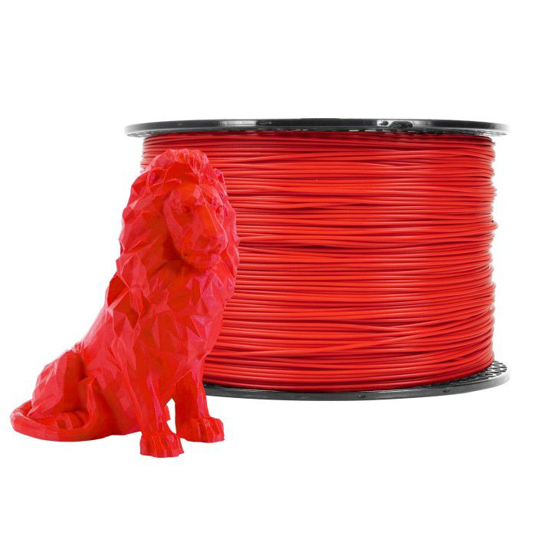

Prusament PLA Lipstick Red 2kg

**€49.99**

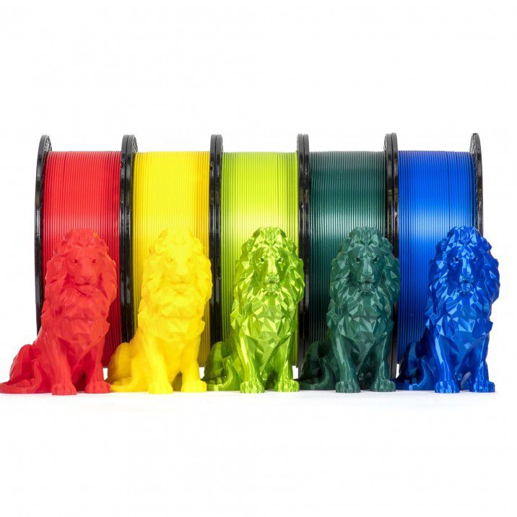

Prusament PLA Extraordinary Pack 4+1 FREE

**€119.99**

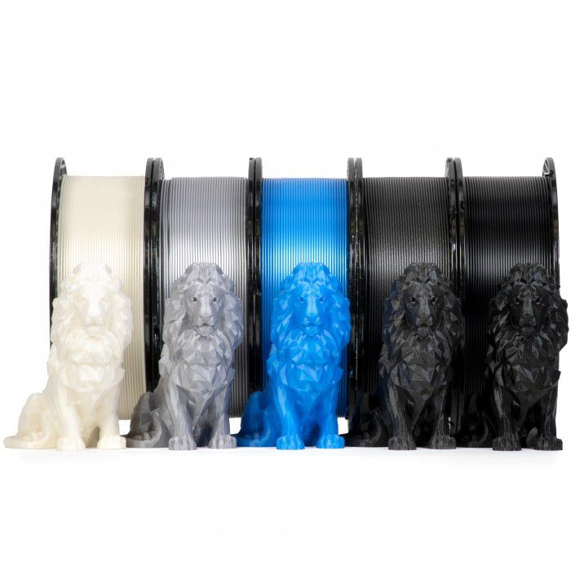

Prusament PLA Best Sellers Pack 4+1 FREE

**€119.99**

**Total filament: €459.95**

**Total: €2027.76 (fara transport)**